Effects of Spin Rate and Batter Handedness on Exit Velocity in the Pioneer League
Hannah F. Dean
College of Arts and Sciences, California Baptist University

Abstract
This study examined whether exit velocity differs across spin rate and tiers (low, med, high) and whether this relationship depends on the batter's side (LHH, RHH) in the Pioneer League during the 2025 season. Data was collected from Trackman and included roughly 31,500 batted balls. A one-way ANOVA test showed a statistically significant difference in exit velocity across spin tiers, with medium spin tiers producing slightly higher exit velocities than low and high spin tiers. A repeated two-way ANOVA tested the effects of handedness and spin tier while limiting the data so that each batter had observations from each spin tier. This analysis showed a statistically significant interaction between spin tier and handedness, indicating that the effect of spin on exit velocity differed slightly between LHH and RHH hitters. Overall, both the one-way and repeated two-way ANOVA showed statistically significant effects on exit velocity. Still, both effects are under 1 mph and have no discernible impact on in-game performance.
Keywords: Spin rate, exit velocity, handedness, Pioneer League, baseball analytics

Effects of Spin Rate and Batter Handedness on Exit Velocity in the Pioneer League
Spin rate refers to the measure of the rotational velocity of a ball thrown in rounds per minute (rpm). It is measured using Doppler radar and High-speed cameras that track the ball's trajectory and rotation immediately after release. The amount of spin on a baseball directly influences its aerodynamic forces, changing how it travels through the air (Nathan, 2007). Spin Rate is one of the main measurements used in defining pitch types because it directly influences break, movement, and effectiveness. Higher spin rates tend to create more movement vertically (vertical break, VB), which can make the pitch appear to “rise”, while lower spin rates tend to create sink, drop, or less overall movement.
Exit velocity refers to the speed at which the ball moves off the bat after contact and is typically used to estimate the overall quality of contact. Higher exit velocities increase the chances of extra-base hits, while lower exit velocities tend to result in weak contact and easily defensive plays. Modern tracking systems like Trackman measure spin rate, exit velocity, and many other variables during a live game, allowing teams to connect pitch design information to hitting outcomes. The more correlation built into stats allows teams to make better coaching decisions and improve game performance. Exit velocity is strongly connected to contact quality and the chance of reaching base, which leads to increased rates of runs scored. Recent analysis on exit velocity has also shown that “exit velocity significantly increased the odds of a batted ball being a hit” (Predicting Batted Ball Outcomes in Major League Baseball, n.d.), contrary to a foul ball.
Batter-handedness is long known to affect contact quality. Previous research has found that hitters tend to produce better contact against pitchers of the opposite hand, and ”hitters cumulatively have better results-based statistics against pitchers of the opposite hand across time periods” (Brown et al., 2023). There are a lot fewer left-handed pitchers than there are right-handed pitchers, and therefore left-handed pitchers tend to have an advantage compared to right-handed hitters due to the trajectory of where the ball is coming from. RHH tend to get the advantage against LHP, and LHH get the advantage against RHP; however, there are many more RHP than there are LHP.
Even though spin rate has become a significant part of pitch design and pitcher development, there is still limited research on how spin affects hitters and batted-ball outcomes, especially outside the MLB and among groups with lower performance levels. Most research on spin rate focuses on pitch movement or swing decisions, not on how it directly affects contact quality. Given the lack of research, this study was designed to examine how spin rate relates to exit velocity, an important factor in contact quality, and whether the relationship between spin rate and exit velocity differs for LHH and RHH hitters.
This study uses Pioneer League data, which extends the research primarily conducted on MLB datasets and provides a better understanding of how spin-related contact plays out in real-game situations at a lower yet still professional level. The Pioneer League is an independent baseball league; it is still professional baseball, but it is at a lower level than single-A.
The purpose of this study is to test whether spin rate relates to exit velocity and whether batter handedness changes that correlation in real Pioneer League games.
Research Question & Hypotheses
Does exit velocity differ across Spin Rate Tiers?
There is no statistically significant difference in mean exit velocity across the low, med, and high spin rate tiers. H_{0A}(EV): μLow = μMed = μHigh.
There is a statistically significant difference in mean exit velocity across at least one spin rate tier (low, med, or high). H_{1A}(EV): μLow ≠ μMed ≠ μHigh.
Does exit velocity differ between batter handedness?
Left-handed hitters and right-handed hitters show no statistically significant difference in mean exit velocity. H_{0B}(EV): μLHH = μRHH.
Left-handed hitters and right-handed hitters show a statistically significant difference in mean exit velocity. H_{1B}(EV): μLHH ≠ μRHH.
Does the influence of spin rate on exit velocity depend on batter handedness?
Spin rate tier and batter handedness do not interact in the prediction of exit velocity; the effect of spin rate is the same for both left-handed and right-handed hitters. H_{0AB}(EV): (Spin Rate x handedness) = 0.
Spin rate tier and batter handedness interact in the prediction of exit velocity, such that the effect of spin rate shows a statistically significant difference in left-handed and right-handed hitters. H_{1AB}(EV): (Spin Rate x handedness) ≠ 0.

Method

Dataset

The study uses Pioneer League Baseball (PBL) Data from the 2025 Season. The data was collected using the TrackMan V3 Stadium game-tracking device, which measures approximately 160 variables related to offensive and defensive metrics. A CSV file is generated for each game.
For the study, the official CSV files were combined into a single file, containing roughly 480 games played from May to September in 2025. The data was cleaned by removing all rows without a hit ball and those with NAs. A new dataset was then created, retaining only the study-specific variables. Thus, including the independent variables, spin rate, and batter side, as well as the dependent variable measured, exit speed. After cleaning the dataset, there were 31503 usable rows.

Study Design
This study measured how exit velocity changed as a function of two factors. Factor A was spin rate tier, with three levels (low, med, high) split by quantiles, yielding 10744 observations per level. Factor B was handedness, which had two levels (RHH & LHH). To run a repeated two-way ANOVA, handedness became a between-subjects factor, measuring each hitter with only one handedness, and spin tier became a within-subjects factor, thus shrinking the data set because each batter had to hit a ball from each spin rate tier. After creating the accurate dataset for repeated two-way ANOVA, the spin rate levels had 327 observations per level, and there were 351 observations for LHH and 630 observations for RHH. Thus giving us enough data for accurate results in the study.
Statistical Models
Let Y_{ij} denote the exit velocity (mph) of the j-th batted ball in spin rate tier i (Low, Med, High). The One-Way ANOVA model is
Y_{ij} = μ + Ƭ_{i} + ε_{ij ,}
Where μ is the overall mean exit velocity, Ƭ_{i} is the effect of spin rate tier i, and ε_{ij} is random error assumed to be independent and normally distributed with mean zero and constant variance ơ².
Let Y_{ijk} denote the mean exit velocity (mph) for batter k, with handedness i (LHH or RHH), at spin rate tier j (Low, Med, High). The repeated Two-Way_ANVA model is
Y_{ijk} = μ + 𝛼_{i} + ꞵ_{j} + (𝛼ꞵ)_{ij} + s_{k} + (ꞵs)_{jk} + ε_{ijk} ,
Where μ is the overall mean exit velocity, 𝛼_{i} is the effect of batter handedness, ꞵ_{j} is the effect of spin rate tier, (𝛼ꞵ)_{ij} is the handedness x spin tier interaction, s_{k} is the random effect of batter k, (ꞵs)_{jk} represents subject-by-spin tier error for the repeated factor, and ε_{ijk} is residual error.
In mixed-model form, this corresponds to
ExitVelocity_{ijk} = μ + 𝛼_{i} + ꞵ_{j} + (𝛼ꞵ)_{ij} + u_{k} + ε_{ijk} ,
With random intercepts u_{k} for each batter.

Results
Table 1

Descriptive Stats
Handedness | Spin Tier | Count | Mean | SD
LHH | Low | 3954 | 84.50034 | 15.17657
LHH | Medium | 3827 | 86.16280 | 14.90435
LHH | High | 3532 | 85.17454 | 14.93807
RHH | Low | 6530 | 85.64643 | 16.14641
RHH | Medium | 6682 | 86.06730 | 15.75653
RHH | High | 6978 | 85.14899 | 15.79439
Total | Total | 31503 | 85.49149 | 15.59235

Across all hitters and spin rate tiers, the average exit velocity was roughly 85.49 mph with a SD ≈ of 15.59. For LHH, exit velocity ranged from 84.5 mph in the low-spin tier to 86.16 mph in the medium-spin tier, with the high-spin tier at 85.17 mph. For RHH, the mean exit velocity ranged from 85.65 mph in the low-spin tier, jumping to the medium-spin tier, with a max mean exit velocity of 86.07, and the high tier at 85.15. In both LHH and RHH, the low-spin tier resulted in the lowest exit velocity, the medium-spin tier gave the highest exit velocity, and the high-spin tier fell between the two. However, the differences in the exit velocity are relatively small (<1 mph).
Table 2

One-Way-ANOVA Table
 | DF | Sum Sq | Mean Sq | F Value | P Value
Spin Tier | 2 | 5896 | 2948 | 12.13 | 5.4e-06
Residuals | 31500 | 7652918 | 243

The one-way ANOVA table showed a statistically significant difference in exit velocity across the spin tiers, F(2, 31,500) = 12.1, p < .001. However, although the result is significant for the study, the differences are relatively small (<1 mph), and the average exit velocity remains around 84-86 mph across all measured tiers.
Table 3

Coefficients Table
 | T Value | P Value
Low (vs High) | .263 | .792
Med (vs High) | 4.393 | 1.12e-05 ***

The coefficients table shows that the Medium (vs High) spin produced an exit velocity approximately 1 mph higher than the high-spin rate, which is statistically significant at p < .001. However, Low (vs High) spin gave a similar exit velocity to the high spin tier (p = .79). These differences are significant but minimal (<1 mph) in terms of the big picture, which means the results might not matter very much in a real game situation.
Table 4

Tukey HSD Table
 | diff | lwr | upr | P adj
Low-High | 0.05661143 | -0.4476353 | 0.5608582 | 0.9625534
Med-High | 0.94450239 | 0.4405560 | 1.4484488 | 0.0000333
Low-Med | 0.88789097 | 0.3836322 | 1.3921497 | 0.0001090

The Tukey HSD post-hoc test confirmed that medium spin was significantly higher than high spin, and low spin was not significantly different from medium or high spin. Overall, medium spin has the highest exit velocity, but the difference is only about 1 mph, which is really small.
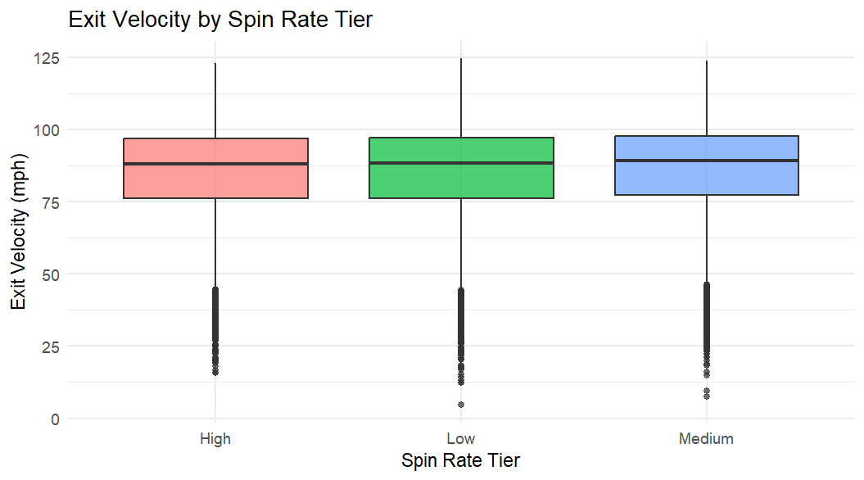
Figure 1
Exit Velocity by Spin Rate Tier Barchart
Note. Error bars represent ± standard error across pitchers.

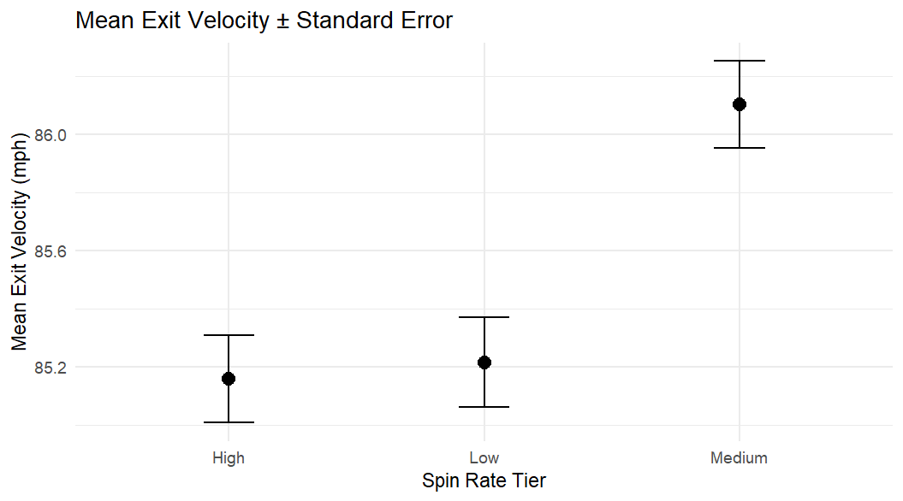
Figure 2
Exit velocity distributions by spin rate and handedness.
Note. Boxplots compare exit velocity across spin tiers and between batter handedness groups (LHH and RHH).

Overall, the one-way ANOVA found a significant difference in exit velocity across spin tiers, but the actual size of the difference is small (<1 mph). Medium spin had the highest exit velocity, but all results stayed within 1 mph of each other.
Table 5

Repeated Measures ANOVA Table
 | df | F | P
Handedness | 1, 325 | 9.958025e-01 | 0.319070706
Spin Tier | 2, 650 | 6.270244e-01 | 0.534501750
Handedness: Spin Tier | 2, 650 | 4.658593e+00 | 0.009798558 *

The repeated two-way ANOVA showed no main effect of spin tier and no main effect of handedness once every hitter hit within each spin tier range. However, the interaction between spoon tier and handedness was statistically significant, which means the effect of spin depends on whether the hitter is a LHH or an RHH.
Table 6

Mauchly’s Test Table
 | W | P Value
Spin Tier | 0.9781401 | 0.02785952 *
Handedness: Spin Tier | 0.9781401 | 0.02785952 *

Mauchly’s test showed that the assumption of sphericity was violated, so Greenhouse-Geisser corrected values were used for the repeated measures part of the analysis.
Table 7

Greenhouse–Geisser and Huynh–Feldt Table
 | GG adj. P | HF adj. P
Spin Tier | 0.53116840 | 0.5320888
Handedness: Spin Tier | 0.01030204 * | 0.0101615 *

After applying the Greenhouse-Geisser and Huynh-Feldt corrections, the interaction between spin tier and handedness remained statistically significant, which means this result did not change even after adjusting the model.
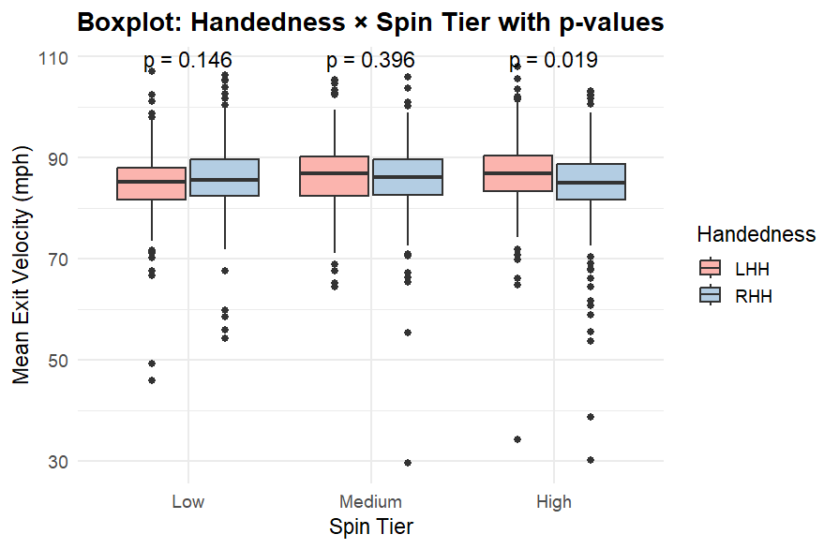
Figure 3
Mean exit velocity with ± standard error bars.
Note. Higher spin rates showed slightly higher mean exit velocity, but the practical differences were minor.
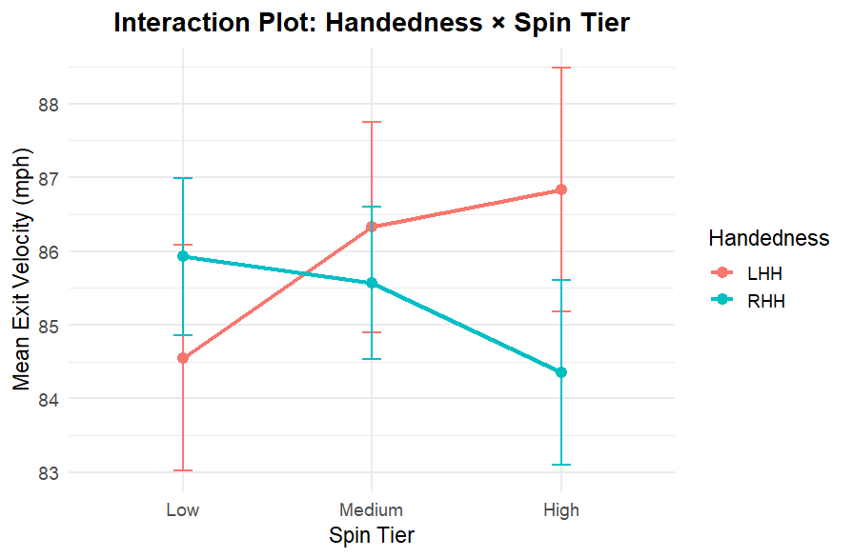
Figure 4
Interaction between spin tier and batter handedness on mean exit velocity.
Note. This interaction plot compares mean exit velocities across three spin rate tiers for left-handed (LHH) and right-handed (RHH) batters. Lines that are close to parallel indicate little evidence of an interaction effect.

Overall, the repeated two-way ANOVA suggests that spin tier and handedness interact only in a small extent. The results were statistically significant, but, similar to the one-way ANOVA, the actual difference in exit velocity was small (<1 mph) and not particularly important in in-game play. Spin rate itself didn't have a significant effect, and hitters mostly stayed within the same exit velocity range across the different spin tiers.

Discussion
Limitations
This study used only PBL data from one season, so the results differ across leagues and levels of baseball. Also, exit velocity, spin rate, and batter handedness were the only variables measured in the study; however, many other factors, such as pitch type, pitch location, and hitter skill level, could also affect exit velocity. There was no separation by pitch type, so that different pitches may interact with spin differently. Another limitation is that not every hitter had data in all three spin tiers, so many repeated measures were missing, taking the data set from 31,500 to 981, which could affect the results.
Future Research
Future research could examine how spin rate interacts with pitch type and pitch location to affect exit velocity or other hitting outcomes, such as launch angle or barrel rate. It would also be interesting to test these patterns in MLB data to see whether the same trend holds at higher levels of baseball. Another interesting study would use a mixed-effects model that includes pitch type and pitcher effectiveness, such as stuff+, to compare how different pitchers create different contact quality based on their pitch profiles. By adding more pitcher and hitter variables, there would be more explanation of the variation in exit velocity.
Practical Implications
Although the measured results were statistically significant, the differences in exit velocity across spin tiers were relatively small (<1 mph). So, stating that coaches and pitchers should expect that increasing spin rate alone will dramatically reduce exit velocity is not accurate. The slight interaction between spin and handedness suggests that LHH might perform slightly differently at certain spin levels. Still, these effects remain small (<1 mph) and insufficient to change coaching strategies. Overall, these results show that pitch design decisions should not rely on spin rate.
Conclusion
In conclusion, spin rate by itself did not have a substantial effect on exit velocity in the 2025 Pioneer League dataset. Medium spin did produce slightly higher exit velocities, and there was a small (<1 mph) interaction between handedness, but these results were relatively small (<1 mph) in actual size. Overall, spin is not a significant factor in determining exit velocity for hitters. More research with more variables and at different levels of performance would help clarify how spin really affects batted-ball outcomes.

References
Brown, M., Ginsburg, E., Lorentzatos, L., & Xiong, R. (2023). Does handedness still matter in the MLB? Unpublished manuscript.
Nathan, A. M. (2007). The effect of spin on the flight of a baseball. American Journal of Physics, 76(2), 119–124.
Predicting Batted Ball Outcomes in Major League Baseball. (2019). Unpublished manuscript.
TrackMan Baseball. (n.d.). TrackMan baseball technology overview. TrackMan. https://trackman.com/baseball
Pioneer Baseball League. (n.d.). Pioneer Baseball League. https://pioneerleague.com

